Name________________________
Date___________ #_____
7th Grade Math Basic Test 1 - http://www.prepdog.org/7th/7mb1.htm
# | Answer | Show me how your brain works. Explain or sketch how you solved the problem. | Understanding
1.
2.
3.
4.
5.
6.
7.
8.
9.
10.
11.
12.
13.
14.
15.
16.
17.
Total correct: ____/17

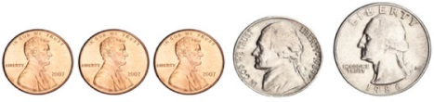
Write an equation for adding up all the money (use decimals):

http://www.prepdog.org/7th/7mb1.htm Prepdog.org- copyright 2014

